**(1) Import library’s and define VGG16 model :**

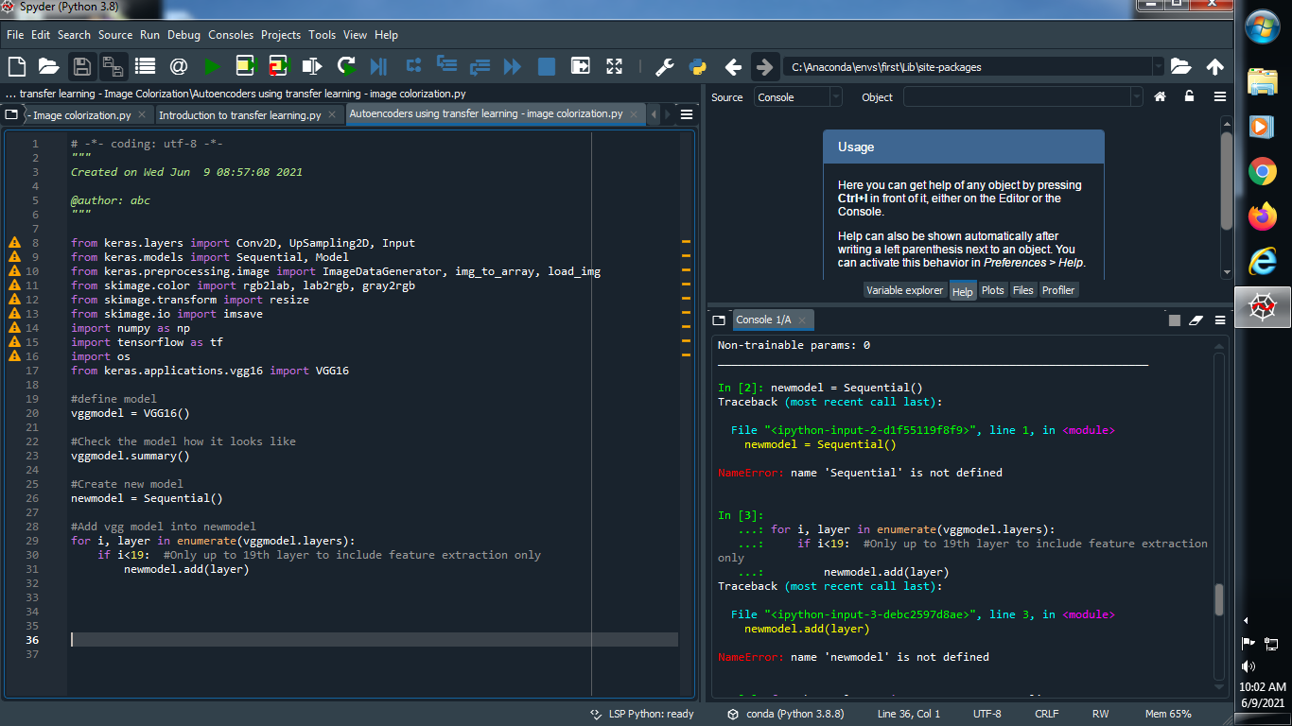

**(2) Check the summary of vgg16 model :**

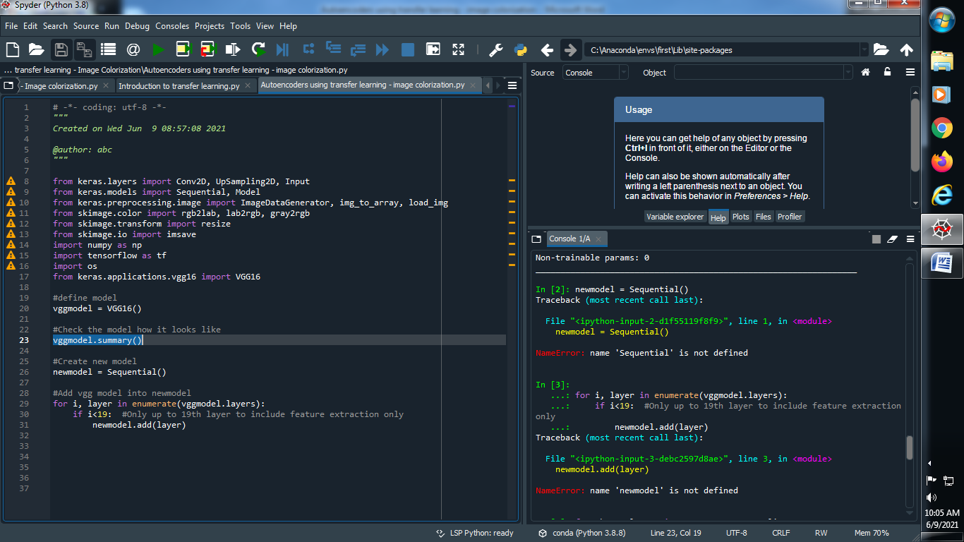

**Output :**

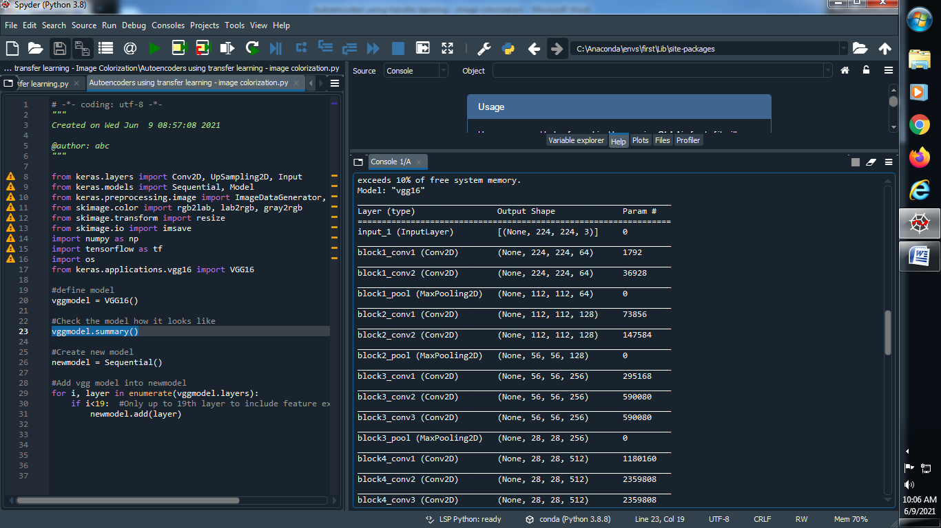

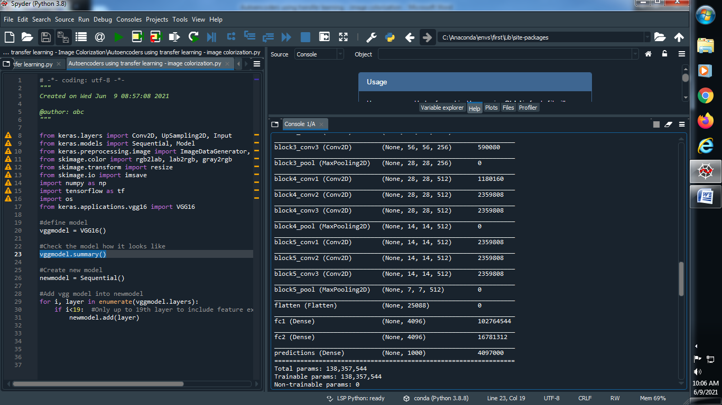

**(3) Create a new empty model and add VGG16 model into it :**

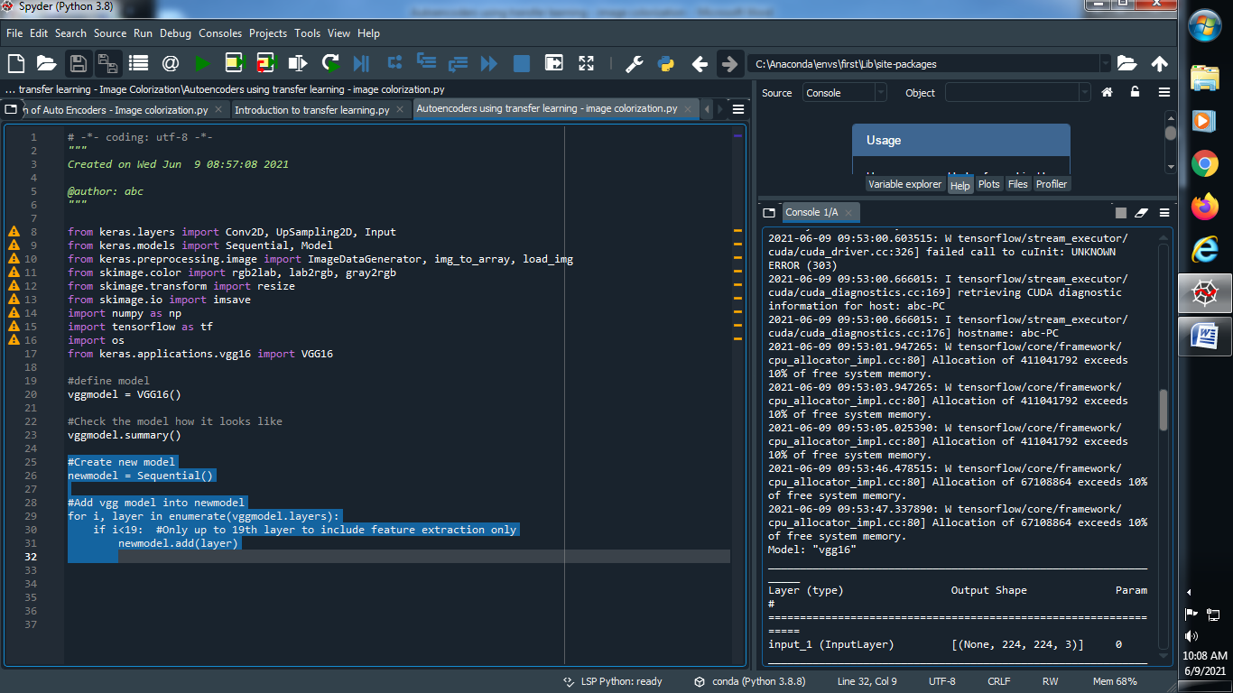

**(4) Let’s check summary of new model :**

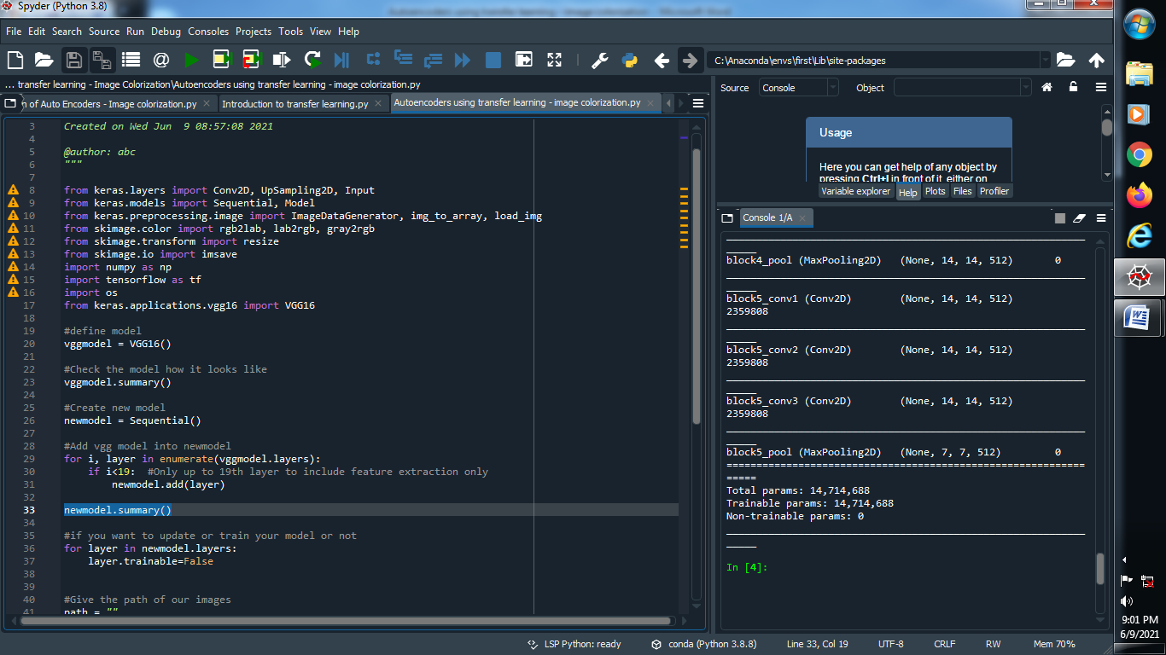

**Output :**

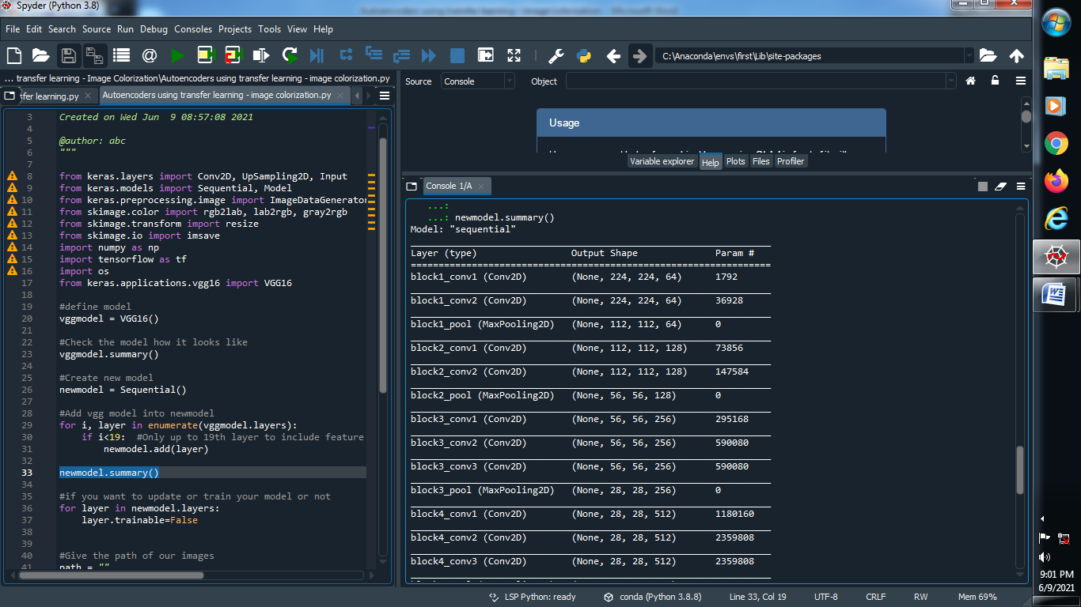

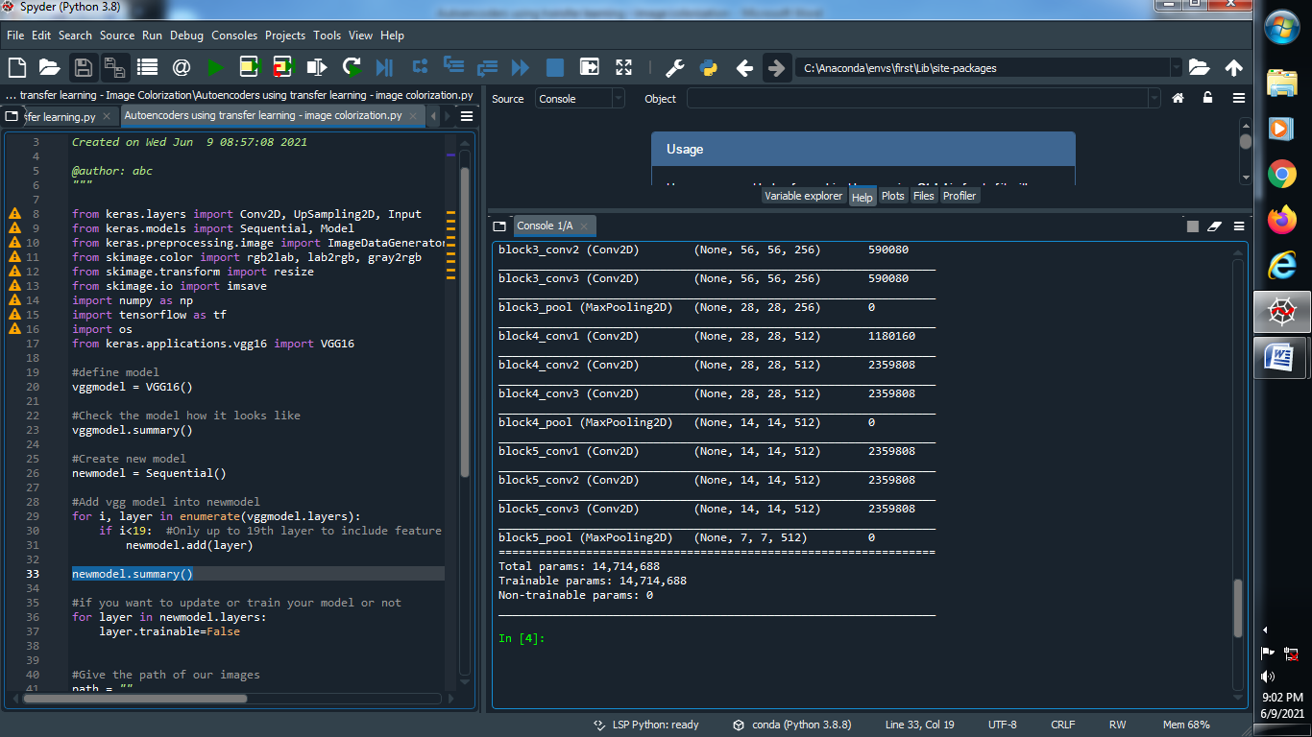

**(5) If you want to update or train your model or not :**

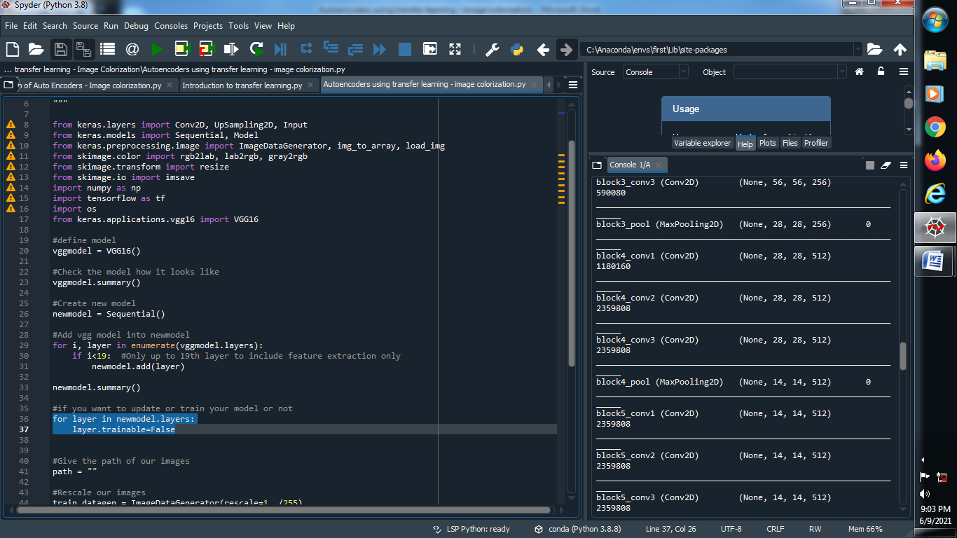

**(6) Give the path of our images and rescale it :**

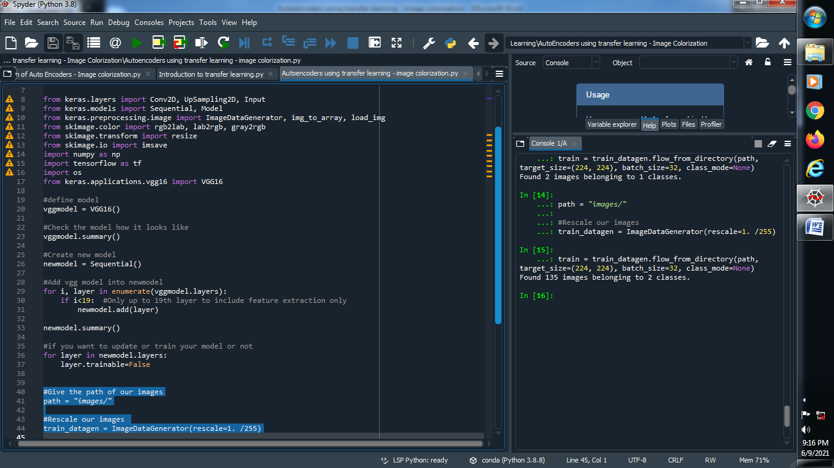

**(7) Train our images :**

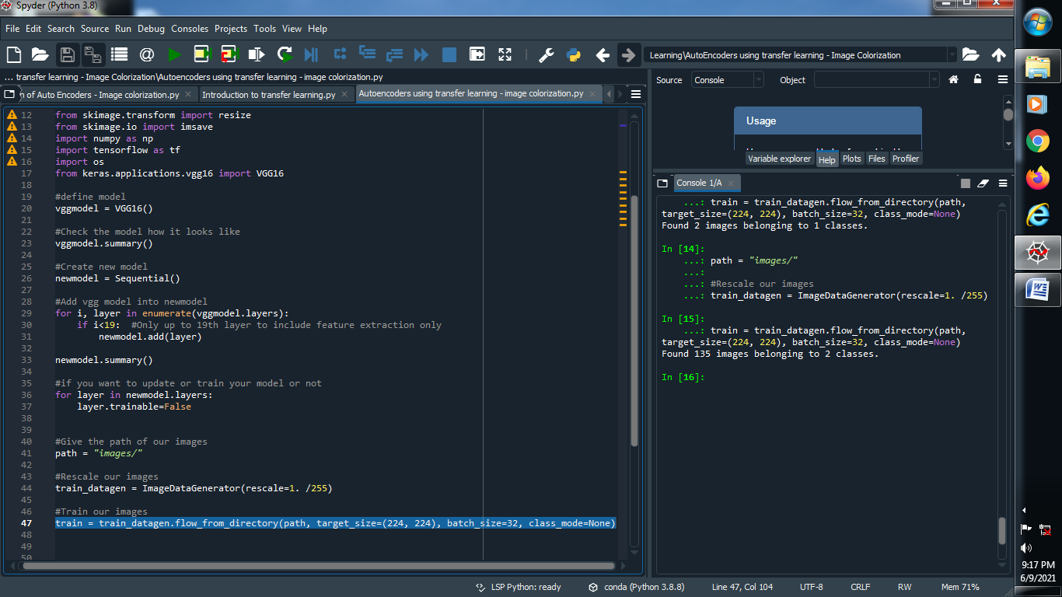

**(8) Convert Our RGB images into LAB format :**

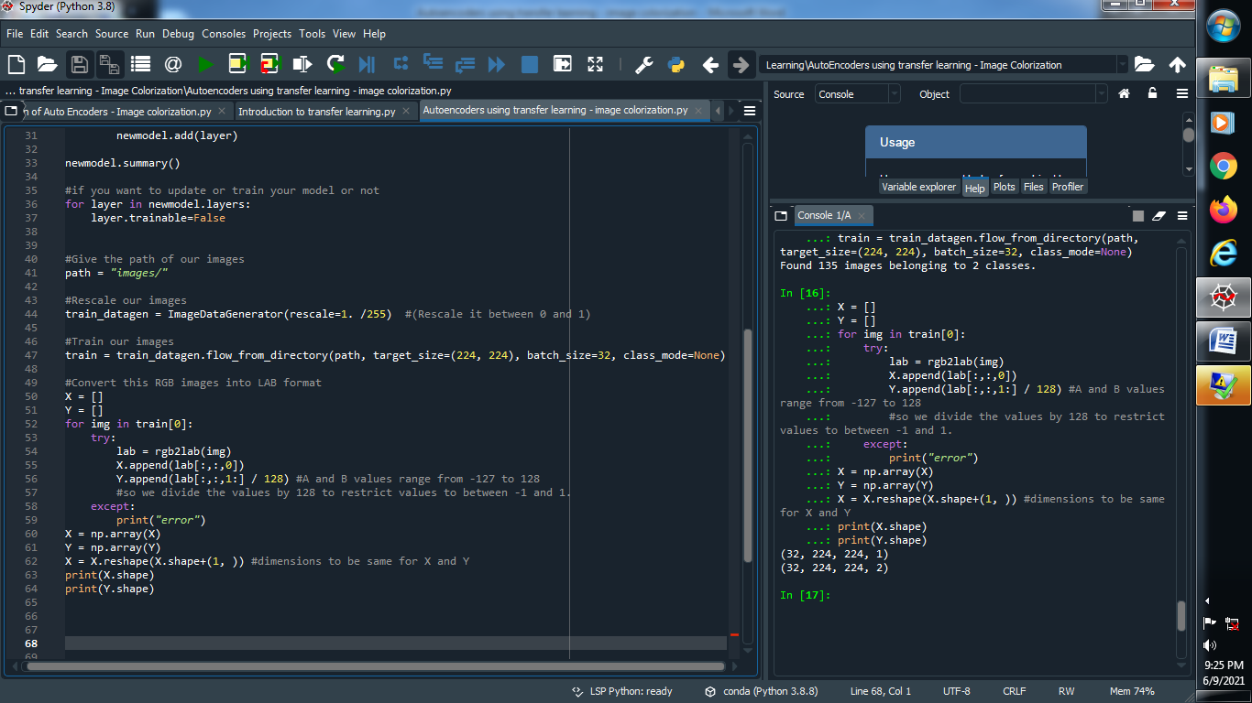

**Output :**



**(9) Convert LAB images into VGG16 format :**

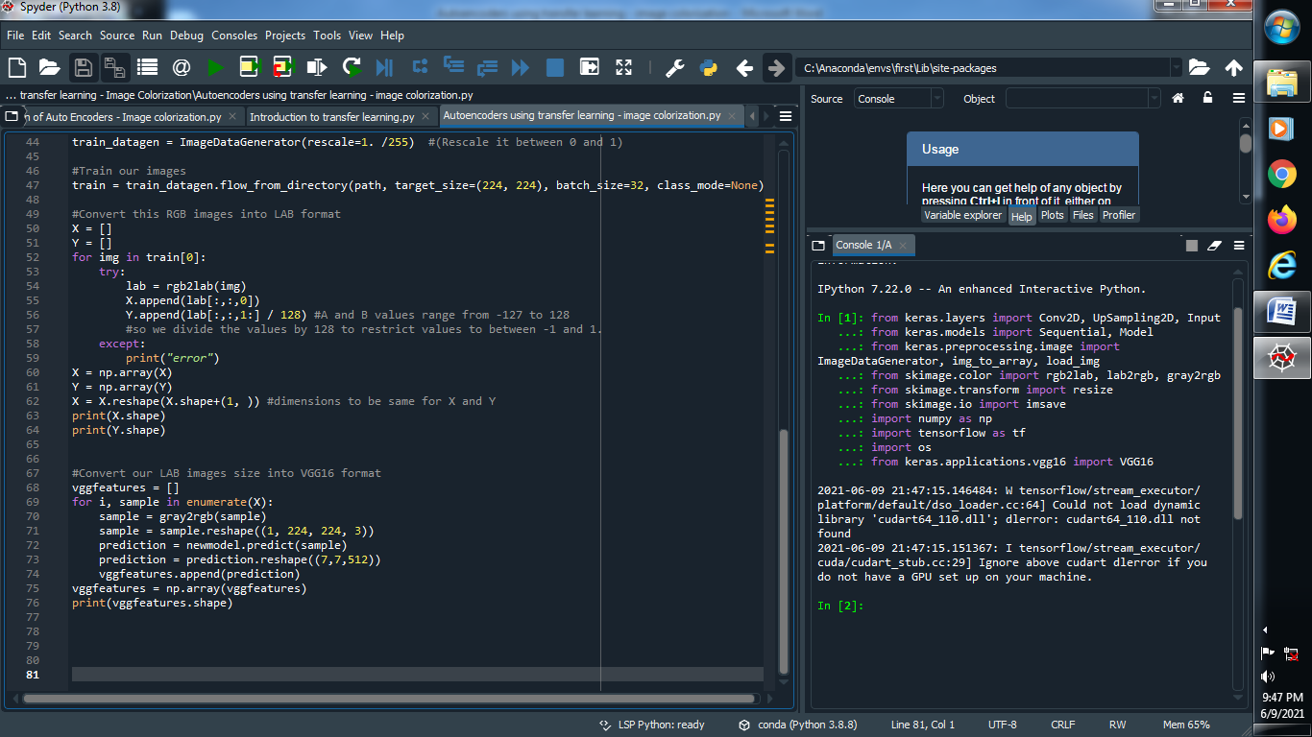

**Output :**

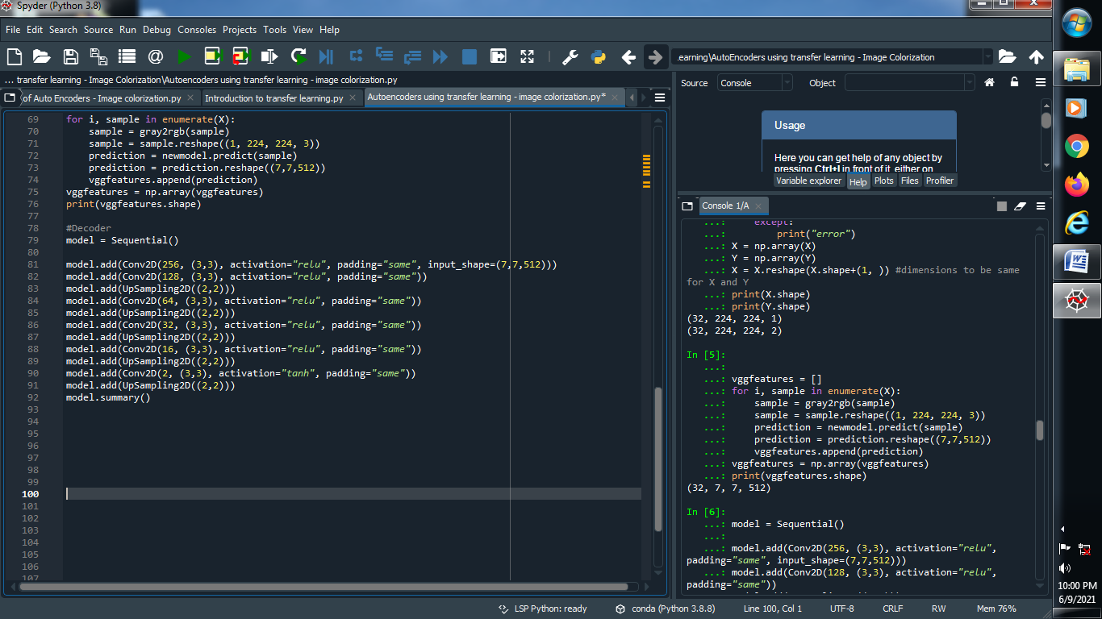

**(10) Define Decoder :**

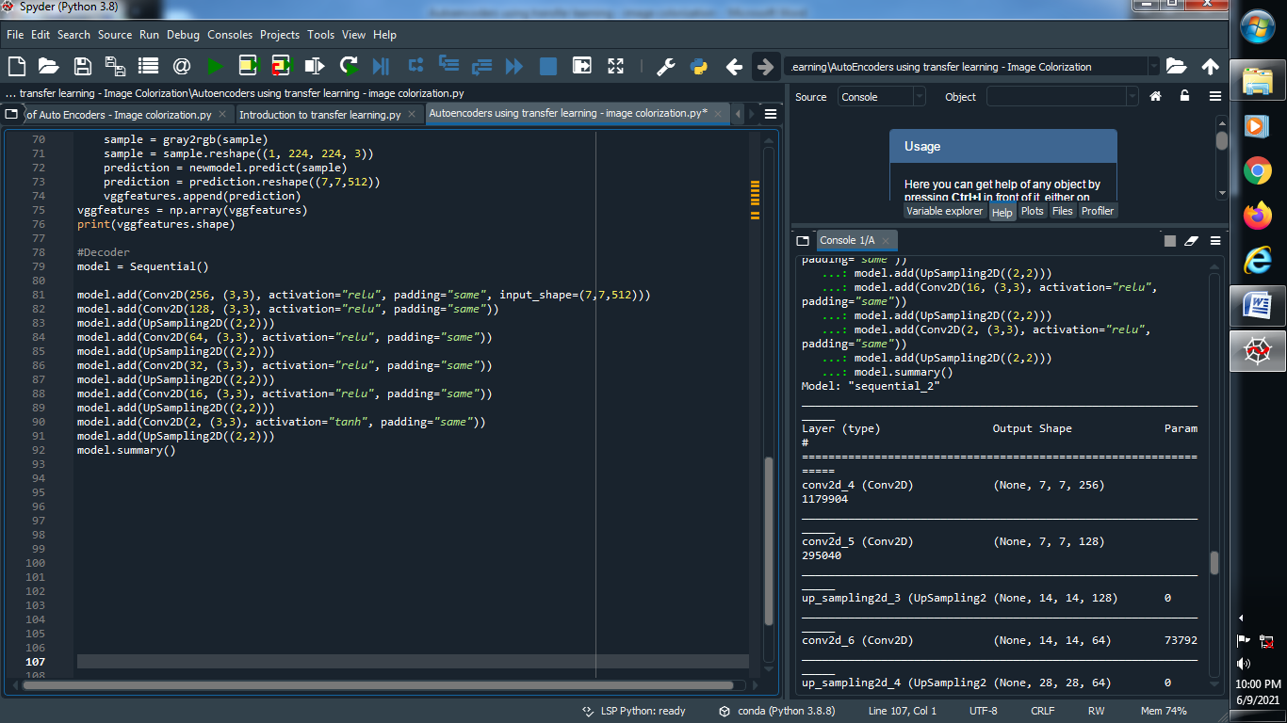

**Output :**

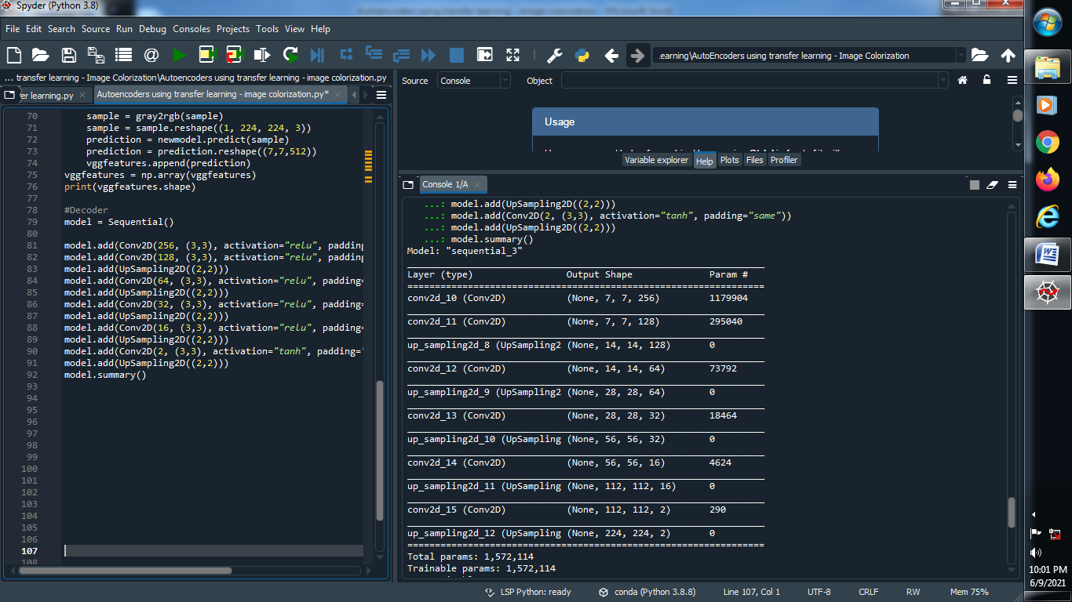

**(11) Compile and fit the model and find accuracy :**

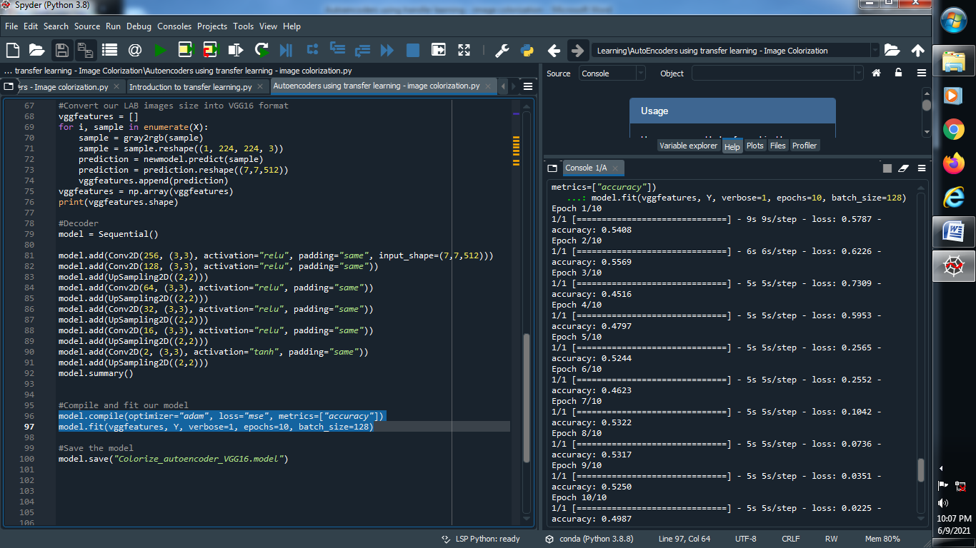

**Output :**



**(12) Save the model :**

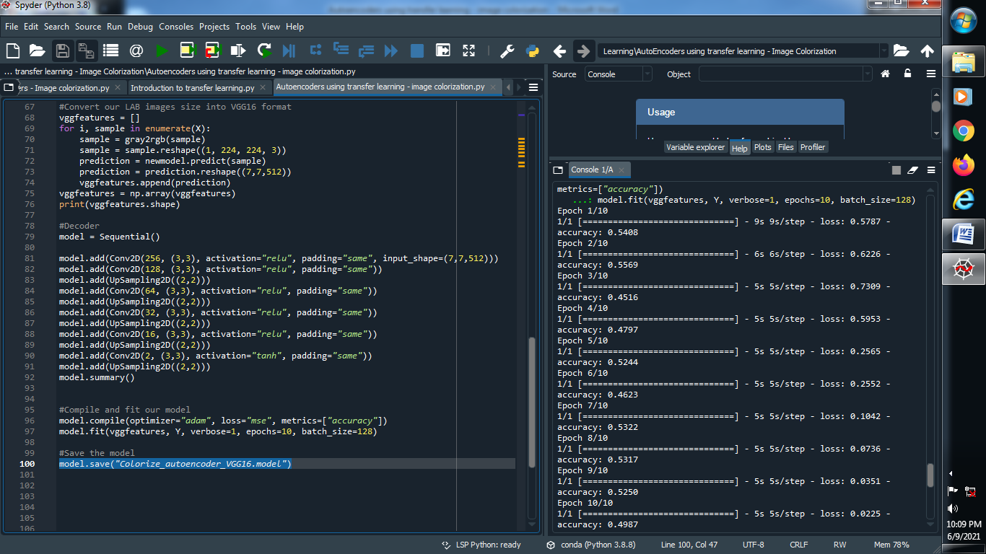

**Output :**

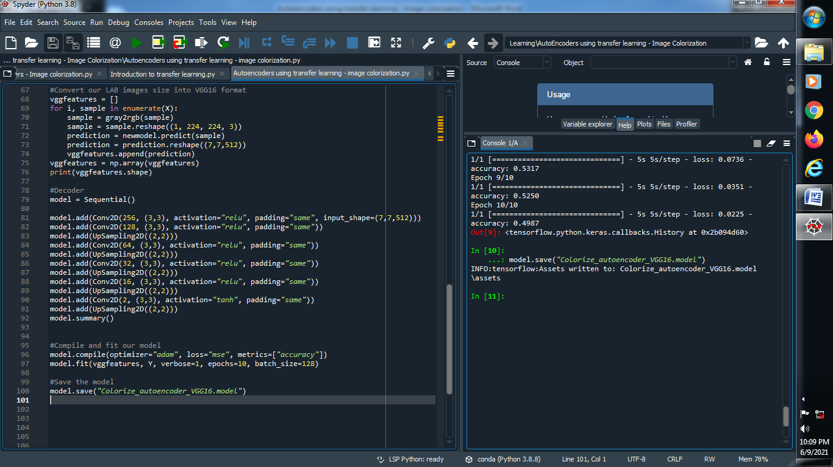

**(13) Predicting using saved model :**

